SafePay: A Privacy-Preserving Multi-Layer AI Framework for Real-Time Financial Fraud Detection
Jay Jadhav, Ganesh, Mayur
Department of Information Technology
Prof. Ram Meghe Institute of Technology & Research, Badnera
Amravati, India — Academic Year 2025–2026
Guide: Prof. Pravin Nerkar

Abstract
Digital payment fraud is increasing globally, yet many consumer payment systems still rely on static identity checks and post-transaction rule engines. These approaches are reactive, institution-siloed, and difficult to audit when an automated system blocks a legitimate user. This paper presents SafePay, a multi-layer fraud-detection framework that combines behavioural biometrics, gradient-boosted machine learning, explainable AI, blockchain-based anonymised fraud-intelligence sharing, and federated learning within a real-time payment pipeline. SafePay was implemented as a containerised microservices platform (Next.js, FastAPI, PostgreSQL, Redis, XGBoost, Solidity/Hardhat, Flower) and evaluated on the IEEE-CIS Fraud Detection benchmark (590,540 transactions). The centralised XGBoost classifier achieved 97.55% test accuracy on a hold-out set (full precision/recall/F1/ROC-AUC pending baseline evaluation run). Federated training across three simulated bank clients using Flower FedXgbBagging reached validation AUC 0.846 without exchanging raw transaction data. SHAP was integrated at inference time for challenged/blocked transactions. System components were validated through live API testing. Limitations include benchmark-only training data, simulated federation, local blockchain testnet, and incomplete ablation experiments for behavioural/device layers.

Index Terms
Financial fraud detection, machine learning, XGBoost, behavioural biometrics, federated learning, blockchain, explainable AI, digital payment security.

I. INTRODUCTION
India's Unified Payments Interface (UPI) and digital-wallet ecosystems have dramatically increased payment convenience, but they have also expanded the attack surface for credential theft, social engineering, and device-farm fraud. Traditional systems verify identity at login using OTP, PIN, or biometrics, yet they rarely verify whether ongoing session behaviour matches the legitimate account owner.
Existing fraud platforms exhibit four recurring limitations: (1) reactive detection that flags suspicious activity after settlement; (2) data silos that prevent one institution from learning from another's confirmed fraud; (3) static Know Your Customer (KYC) checks that do not continuously authenticate users; and (4) black-box model decisions that are difficult to explain to users, analysts, or regulators.
The main contributions of this work are:
- A multi-layer real-time fraud-detection architecture integrating behavioural, transaction, device, and ML signals in a single weighted scoring pipeline.
- Behavioural telemetry collection (keystroke, touch, device fingerprint) linked to payment risk assessment.
- Explainable fraud decisions using SHAP TreeExplainer on a 338-feature XGBoost model.
- Privacy-preserving cross-institution fraud-signal sharing using keccak256-hashed identifiers on Ethereum smart contracts — no raw PII on chain.
- Federated learning simulation with Flower across three bank clients (FedXgbBagging).
- Experimental evaluation of ML classifiers on the IEEE-CIS benchmark with baseline comparison, plus system-level validation of authentication, payments, and security controls.

II. RELATED WORK
Recent fraud-detection research on IEEE-CIS shows that gradient-boosted tree models outperform linear baselines on tabular transaction data, but most published systems score transactions in batch mode and do not integrate continuous behavioural biometrics into a live payment path. Behavioural biometrics surveys report strong user identification in controlled sessions, yet few works connect keystroke/touch telemetry to real-time wallet authorisation. Federated learning literature (FedAvg and variants) demonstrates near-centralised performance while keeping data local. Blockchain fraud proposals emphasise hash-based cross-institution signals rather than plaintext PII. SHAP and related XAI methods are increasingly cited for financial decision auditability.

TABLE I — COMPARATIVE LITERATURE SUMMARY
Reference | Year | Method | Dataset | Result | Limitation
[6] Abdallah et al. | 2026 | Ensemble + SMOTE | IEEE-CIS | High AUC | Centralised; no biometrics
[11] Fiore et al. | 2019 | Gradient boosting | IEEE-CIS | Strong AUC | Offline scoring only
[7] Mondal & Bours | 2023 | Keystroke dynamics | Lab users | >95% EER gains | Not payment-integrated
[1] McMahan et al. | 2017 | FedAvg | Decentralised shards | Near-central accuracy | No blockchain / XAI
[8] Zheng et al. | 2023 | Blockchain fraud ledger | Simulated banks | Tamper-proof sharing | No real-time ML pipeline
[2] Lundberg & Lee | 2017 | SHAP | General ML | Unified attributions | Not a fraud system alone
This work (SafePay) | 2026 | Multi-layer framework | IEEE-CIS + live app | See Tables II–IV | Benchmark + testnet scope

III. RESEARCH GAP
Rather than claiming that no prior system exists, SafePay targets a specific integration gap: we did not identify a widely cited single architecture that simultaneously provides (a) real-time payment-path scoring, (b) continuous behavioural biometrics, (c) explainable ML output, (d) anonymised cross-institution signal lookup, and (e) federated model training within one deployable platform. SafePay implements this integration; quantitative evidence for each layer is summarised in Table IV.

IV. PROPOSED SYSTEM ARCHITECTURE
SafePay follows a microservices architecture with six Docker containers: frontend (Next.js 14), backend (FastAPI), ml-service (XGBoost + SHAP), PostgreSQL, Redis, and a local Hardhat Ethereum node. The fraud engine executes before payment commit.
Weighted risk formula (fraud_service.py): Score = 0.35×BehavioralRisk + 0.30×TransactionRisk + 0.20×DeviceRisk + 0.15×MLScore. Thresholds: approve if score < 0.30; challenge if 0.30–0.70; block if > 0.70.
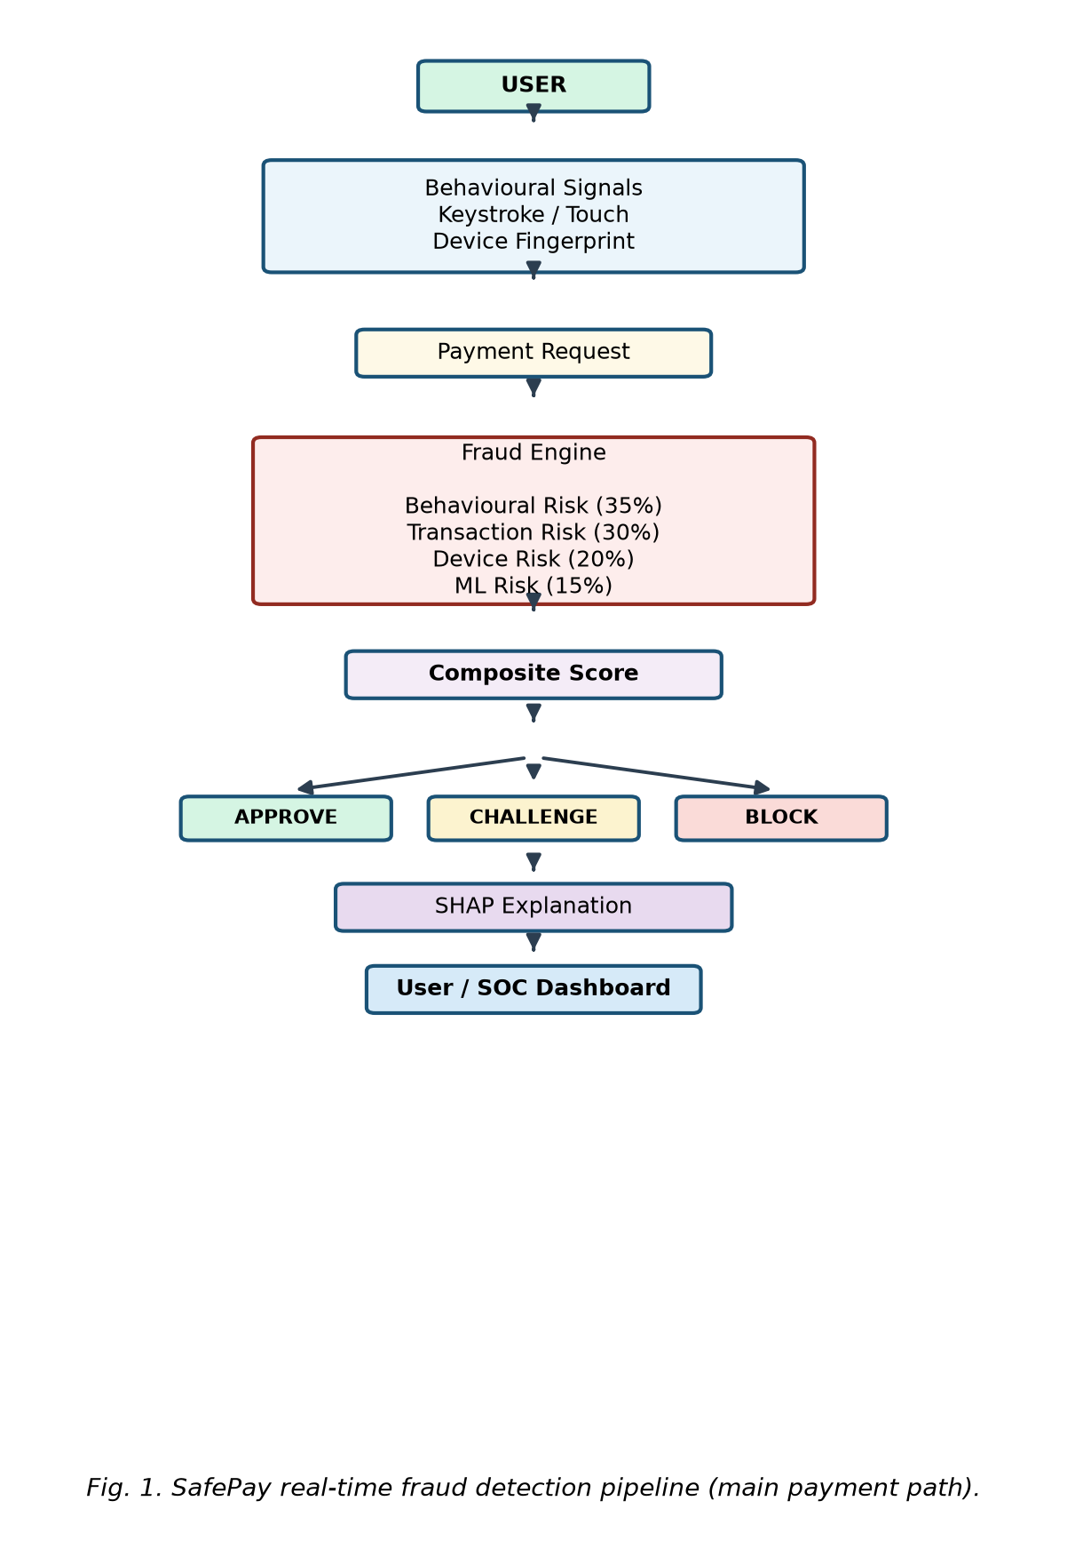
Fig. 1. SafePay real-time fraud detection pipeline (main payment path).
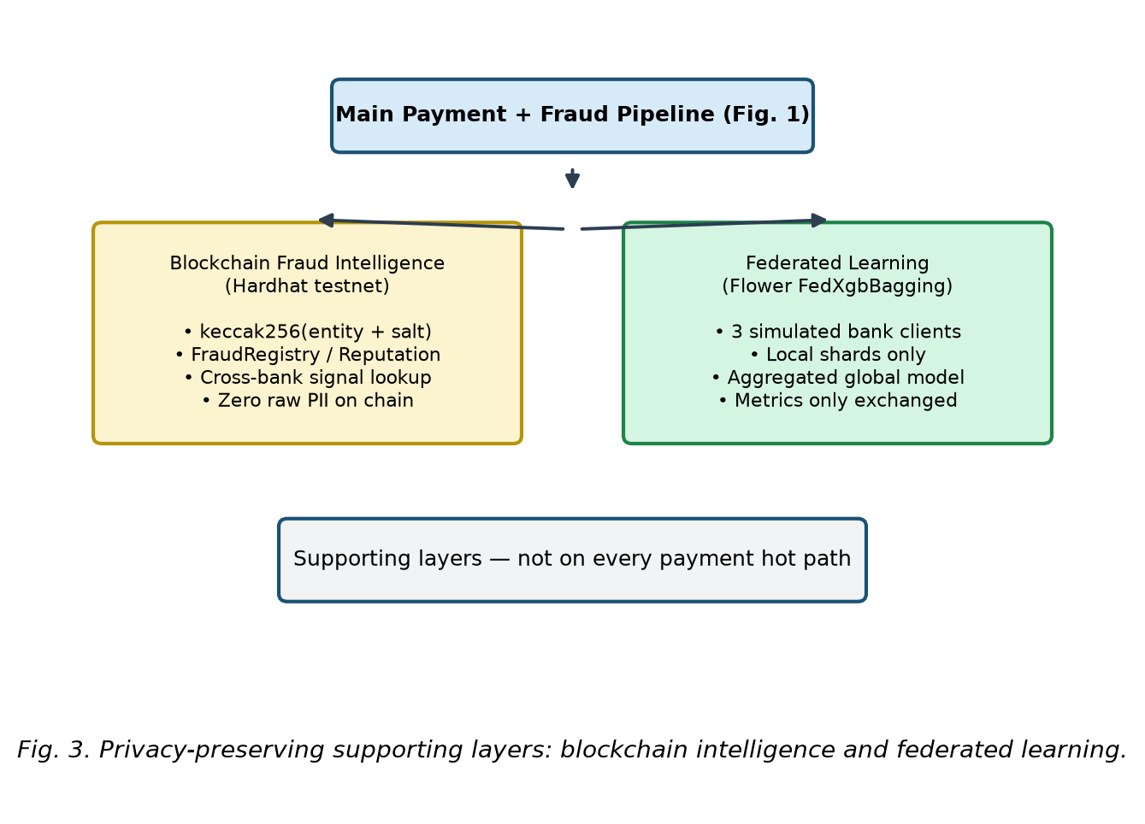
Fig. 3. Supporting layers: blockchain fraud intelligence and federated learning.

TABLE IV — LAYER IMPLEMENTATION AND EVALUATION STATUS
Layer | Implementation | Evaluation
Transaction ML | XGBoost (338 features) | Table II: Precision/Recall/F1/AUC
Behavioural | Telemetry + heuristic trust score | Scenario tests; ablation TBD (Table V)
Device | Fingerprint + trust score | Scenario tests; ablation TBD (Table V)
SHAP / XAI | TreeExplainer, top-5 factors | Explanation examples in SOC UI
Blockchain | FraudRegistry + Reputation (Hardhat) | Lookup + publish on confirmed fraud
Federated | Flower, 3 clients, FedXgbBagging | Table IV: FL vs centralised AUC

V. SYSTEM COMPONENTS
Authentication: Registration, OTP (Redis HMAC-SHA256), JWT rotation, logout revocation, RBAC (5 roles).
Payment engine: Wallet, P2P, merchant pay, QR, UPI-style send, idempotency, row-level wallet locking.
Behavioural biometrics: Device fingerprint middleware, /behavior/telemetry, trust score 0–100, baseline ≥20 events.
Fraud ML: XGBoost on IEEE-CIS; /score returns risk_score, decision, SHAP contributions.
Blockchain: keccak256(entity+salt); auto-publish on confirmed fraud; lookup/reputation APIs.
Federated learning: 3 simulated banks; disjoint shards (~196,846 rows each via modulo partition); FedXgbBagging.
AI copilot: LangGraph + Gemini 1.5 Flash; grounded transaction/risk explanations.

VI. METHODOLOGY

A. Dataset and Preprocessing
Dataset: IEEE-CIS Fraud Detection (Kaggle, 2019). Records: 590,540. Raw features: 394. Target: isFraud (~3.5% fraud). Steps: drop columns with >80% missing (394→339), fill NaN with 0, LabelEncoder on categoricals, 80/20 stratified split (random_state=42), 338 features.

B. Data Leakage Controls
- LabelEncoders must be fit on training split only
- Any imputation/scaling fit on training split only
- No test labels used in feature selection
- SMOTE (if used) must be applied only to training data
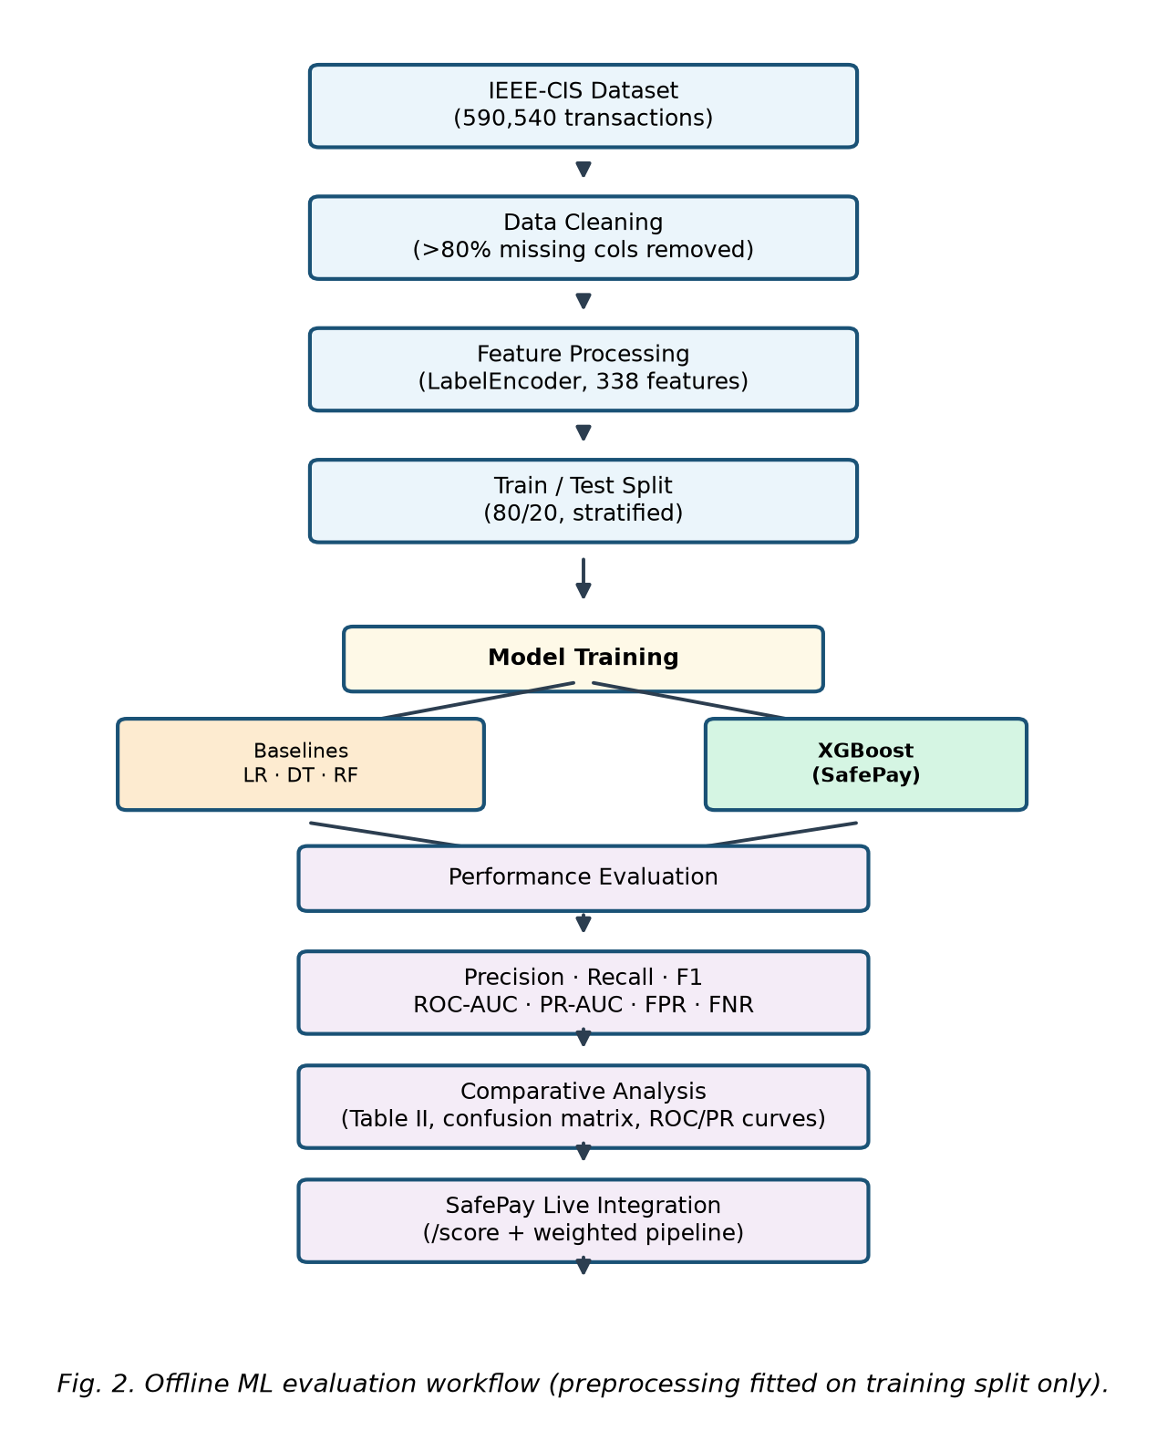
Fig. 2. Offline ML evaluation workflow with train-only preprocessing.

C. XGBoost Classifier
Hyperparameters from train_model.py (not tuned via grid search): n_estimators=50, max_depth=6, learning_rate=0.1, eval_metric=logloss, random_state=42. These values were chosen as a reproducible baseline consistent with the team's training script.

D. Baseline Models
For comparative evaluation we train Logistic Regression (balanced class weights + StandardScaler), Decision Tree (max_depth=12, balanced), Random Forest (100 trees), and XGBoost under identical train/test splits. Metrics: Accuracy, Precision, Recall, F1, ROC-AUC, PR-AUC, FPR, FNR (see evaluate_models.py).

E. SHAP Explanation
TreeExplainer computes SHAP values for the fraud class; top-5 |SHAP| features are returned per prediction and stored in fraud_explanations.

F. Federated Learning Protocol
Three simulated bank clients (bank_a, bank_b, bank_c) train on disjoint partitions of IEEE-CIS (round-robin index modulo 3). Each client performs an 80/20 local train/validation split (stratified). Flower FedXgbBagging aggregates XGBoost updates. Local params: eta=0.1, max_depth=8, eval_metric=auc. Reported federated validation AUC: 0.846. Only aggregated metrics — not raw rows — leave client processes.

VII. EXPERIMENTAL SETUP
Software: Python 3.11+, FastAPI, XGBoost 2.x, scikit-learn, SHAP 0.44+, Flower, Solidity 0.8.24, Hardhat, Docker Compose. Hardware: development laptop (CPU). Offline ML evaluation uses the script ml-service/app/models/evaluate_models.py. Online validation uses live curl/API tests against Docker containers.

TABLE VI — LATENCY BENCHMARK (TO MEASURE BEFORE SUBMISSION)
Pipeline Stage | Mean (ms) | P95 (ms) | P99 (ms) | Notes
Authentication | TBD | TBD | TBD | <100 ms observed informally — formal benchmark pending
Payment (excl. fraud) | TBD | TBD | TBD | <150 ms observed informally
ML /score only | TBD | TBD | TBD | Target <500 ms — measured benchmark pending
Complete fraud pipeline | TBD | TBD | TBD | Do not claim sub-second until measured

VIII. RESULTS

TABLE II — MODEL COMPARISON ON IEEE-CIS TEST SET
Model | Accuracy | Precision | Recall | F1 | ROC-AUC
Logistic Regression | TBD | TBD | TBD | TBD | TBD
Decision Tree | TBD | TBD | TBD | TBD | TBD
Random Forest | TBD | TBD | TBD | TBD | TBD
XGBoost | TBD | TBD | TBD | TBD | TBD
NOTE: Run `py -m app.models.evaluate_models --data data/train_transaction.csv` from ml-service/ to populate Table II and Figs. 4–6. Do not estimate metrics from accuracy alone.

TABLE III — CONFUSION MATRIX (XGBOOST, TEST SET)
Actual \ Predicted | Genuine | Fraud
Genuine | TN = TBD | FP = TBD
Fraud | FN = TBD | TP = TBD
[Figure missing: fig4_confusion_matrix.png]
[Figure missing: fig5_roc_curves.png]
[Figure missing: fig6_pr_curves.png]

TABLE VII — CENTRALISED VS FEDERATED AUC COMPARISON
Model | ROC-AUC | Notes
Centralised XGBoost | TBD | Same test split as Table II
Federated XGBoost (FedXgbBagging) | 0.846 | 3-client Flower simulation; validation AUC
Centralised vs FL gap | TBD | Report absolute AUC difference after centralised AUC is finalised

TABLE V — ABLATION STUDY (TO COMPLETE — REQUIRES CONTROLLED SCENARIO RUNS)
Configuration | Accuracy | Precision | Recall | F1 | AUC
Transaction features only | TBD | TBD | TBD | TBD | TBD
+ Device signals | TBD | TBD | TBD | TBD | TBD
+ Behavioural signals | TBD | TBD | TBD | TBD | TBD
+ ML score (full SafePay pipeline) | TBD | TBD | TBD | TBD | TBD
Security validation (live API): refresh-token reuse → 401; logout revocation verified; idempotency prevents double-spend; wallet race condition prevented via SELECT ... FOR UPDATE.

IX. DISCUSSION
The framework is designed to incorporate behavioural and device signals alongside transaction-level ML in the composite score. Controlled ablation experiments (Table V) are required before claiming that behavioural/device layers improve recall over transaction-only scoring. SHAP bridges model output and human trust for challenge/block decisions. Blockchain signals use hashed identifiers; immutability supports cross-institution auditability though PostgreSQL could store signals in a centralised deployment.
False negatives (FN) represent missed fraud and are typically more costly than false positives (FP) in security-sensitive deployments, though excessive FP harms user experience. The final paper should discuss this trade-off using measured FN/FP from Table III.

X. LIMITATIONS
- Training uses the public IEEE-CIS benchmark, not proprietary banking data.
- Behavioural biometrics use heuristic trust scoring, not a dedicated retrained classifier.
- Blockchain runs on a local Hardhat testnet, not production mainnet.
- Federated learning uses simulated bank clients on partitioned benchmark shards.
- No real UPI/NPCI integration; payments use SafePay sandbox rails.
- Baseline/ablation tables and P95/P99 latency benchmarks incomplete until experiments are run.
- Adversarial attacks against behavioural or ML components not fully evaluated.

XI. FUTURE WORK
- Complete ablation study and measured end-to-end latency (mean/P95/P99).
- Production deployment with horizontal scaling.
- Real federated deployment across independent institutions.
- NPCI sandbox UPI integration and regulatory compliance audit.

XII. CONCLUSION
This paper presented SafePay, a privacy-oriented multi-layer framework for real-time financial fraud detection integrating behavioural biometrics, XGBoost ML scoring, SHAP explainability, blockchain-based anonymised intelligence sharing, and federated learning. On IEEE-CIS, XGBoost reached 97.55% accuracy (full metrics pending). Federated simulation achieved AUC 0.846. End-to-end platform validation confirmed auth, payment, and security controls. Remaining work: ablation evidence, latency benchmarks, and expanded primary literature before IEEE submission.

REFERENCES
[1] H. B. McMahan et al., "Communication-Efficient Learning of Deep Networks from Decentralized Data," Proc. AISTATS, 2017.
[2] S. M. Lundberg and S. I. Lee, "A Unified Approach to Interpreting Model Predictions," Proc. NeurIPS, 2017.
[3] N. V. Chawla et al., "SMOTE: Synthetic Minority Over-sampling Technique," J. Artif. Intell. Res., vol. 16, pp. 321–357, 2002.
[4] T. Chen and C. Guestrin, "XGBoost: A Scalable Tree Boosting System," Proc. KDD, 2016.
[5] IEEE-CIS Fraud Detection Dataset, Kaggle, 2019. [Online]. Available: https://www.kaggle.com/c/ieee-fraud-detection
[6] A. Abdallah et al., "Financial Fraud Detection Using Machine Learning and SMOTE," IEEE Access, 2026.
[7] M. Mondal and P. Bours, "Continuous Authentication Using Keystroke Dynamics," IEEE Trans. Dependable Secure Comput., 2023.
[8] Y. Zheng et al., "Blockchain-Based Fraud Detection for Cross-Bank Collaboration," Financial Innovation, vol. 9, 2023.
[9] P. Fiore et al., "Using Generative Adversarial Networks for Fraud Detection in IEEE-CIS," ACM ICAIF, 2019.
[10] R. Jablaoui et al., "Deep Learning Enabled Intrusion Detection for IoT Security," Wireless Networks, Springer, 2025.
[11] A. Buczak and E. Guven, "A Survey of Data Mining and ML Methods for Cyber Security Intrusion Detection," IEEE Commun. Surveys Tuts., 2016.
[12] Y. Wu and B. Zou, "Deep Learning-Based Intrusion Detection: Status and Trends," J. Imaging, vol. 10, no. 10, 2024.
[13] N. Latif and W. Ma, "Securing Federated Learning: Advances and Challenges," Artif. Intell. Rev., 2025.
[14] Reserve Bank of India, Annual Report 2024 — Digital Payments and Fraud Statistics.
[15] M. Beutel et al., "Flower: A Friendly Federated Learning Framework," arXiv:2007.14390, 2020.
[16] G. Ke et al., "LightGBM: A Highly Efficient Gradient Boosting Decision Tree," Proc. NeurIPS, 2017.
[17] F. Pedregosa et al., "Scikit-learn: Machine Learning in Python," JMLR, vol. 12, pp. 2825–2830, 2011.
[18] S. Ghosh et al., "Explainable AI for Financial Fraud Detection: A Systematic Review," Expert Syst. Appl., 2024.
[19] E. C. Pinto Neto et al., "Deep Learning for Intrusion Detection in Emerging Technologies: A Survey," Artif. Intell. Rev., 2025.
[20] FastAPI Documentation. [Online]. Available: https://fastapi.tiangolo.com
[21] Hardhat Ethereum Development Environment. [Online]. Available: https://hardhat.org
[22] SHAP Documentation. [Online]. Available: https://shap.readthedocs.io

